DATA DICTIONARY

Amsterdam – Capital city of the Netherlands

Tourist -- a person who is travelling or visiting a place for pleasure.

Free laws on drug use— the drug Policy in the Netherlands

Red Light District— an area of a town or city containing many brothels, strip clubs, and other sex businesses.

Law -- the system of rules which a particular country or community recognizes as regulating the actions of its members and which it may enforce by the imposition of penalties.

Attractions in Darkrooms— an attraction where costumers engage in sexual activity of some kind

Entertainments— the action of providing or being provided with amusement or enjoyment

Risks— a situation involving exposure to danger

Natives— A person born in a specified place or associated with a place by birth, whether subsequently resident there or not

Restrictive Countries—a country more limited than another country

Website— a set of related web pages located under a single domain name

Full spectrum of information— cultural, recreational, medical, legal, psychic

Visitors--- A person visiting someone or somewhere, especially socially or as a tourist

Knowledge— Facts, information and skills acquired through experience or education

Consequences— the effect, result, or outcome of something occurring earlier

(Medical/Police) Professionals— engaged in a specified activity as one’s main paid occupation rather than as an amateur

Hard Data— Information such as numbers or facts that can be proved

Background – The circumstances or situation prevailing at a particular time or underlying a particular event

Database— a structured set of data held in a computer, especially one that is accessible in various ways

Information— Facts provided or learned about something or someone

Users— A person who uses our website

Policy makers— a person responsible for or involved in formulating policies, especially in politics.

Pages—a hypertext document connected to the World Wide Web

Account— an arrangement in which a person uses the internet or E-mail services of a particular company

Statistics—The practice or science of collecting and analyzing numerical data in large quantities, especially for the purpose of inferring proportions in a whole from those in a reprehensive sample

Prostitutes -- a person, in particular a woman, who engages in sexual activity for payment.

Narcotics -- an addictive drug affecting mood or behavior, especially an illegal one

REMOVING DOUBLES

Amsterdam – Capital city of the Netherlands

Tourist -- a person who is travelling or visiting a place for pleasure.

Free laws on drug use— the drug Policy in the Netherlands

Red Light District— an area of a town or city containing many brothels, strip clubs, and other sex businesses.

Law -- the system of rules which a particular country or community recognizes as regulating the actions of its members and which it may enforce by the imposition of penalties.

Attractions in Darkrooms— an attraction where costumers engage in sexual activity of some kind

Entertainments— the action of providing or being provided with amusement or enjoyment

Risks— a situation involving exposure to danger

Natives— A person born in a specified place or associated with a place by birth, whether subsequently resident there or not

Restrictive Countries—a country more limited than another country

Website— a set of related web pages located under a single domain name

Full spectrum of information— cultural, recreational, medical, legal, psychic information

~~Visitors--- A person visiting someone or somewhere, especially socially or as a tourist~~ -Tourist

Knowledge— Facts, information and skills acquired through experience or education

~~Consequences— the effect, result, or outcome of something occurring earlier~~ - risks

(Medical/Police) Professionals— engaged in a specified activity as one’s main paid occupation rather than as an amateur

Hard Data— Information such as numbers or facts that can be proved

Background – The circumstances or situation prevailing at a particular time or underlying a particular event

Database— a structured set of data held in a computer, especially one that is accessible in various ways

Information— Facts provided or learned about something or someone

Users— A person who uses our website

Policy makers— a person responsible for or involved in formulating policies, especially in politics.

Pages—a hypertext document connected to the World Wide Web

Account— an arrangement in which a person uses the internet or E-mail services of a particular company

Statistics—The practice or science of collecting and analyzing numerical data in large quantities, especially for the purpose of inferring proportions in a whole from those in a reprehensive sample

Prostitutes -- a person, in particular a woman, who engages in sexual activity for payment.

Narcotics -- an addictive drug affecting mood or behavior, especially an illegal one

CATAGORIZING

Law -- the system of rules which a particular country or community recognizes as regulating the actions of its members and which it may enforce by the imposition of penalties.

Natives— A person born in a specified place or associated with a place by birth, whether subsequently resident there or not

Tourist -- a person who is travelling or visiting a place for pleasure.

(visitor) Background – The circumstances or situation prevailing at a particular time or underlying a particular event

(visitor) Knowledge— Facts, information and skills acquired through experience or education

Restrictive Countries—a country more limited than another country

Entertainments— the action of providing or being provided with amusement or enjoyment

Free laws on drug use— the drug Policy in the Netherlands

Narcotics -- an addictive drug affecting mood or behavior, especially an illegal one

Risks— a situation involving exposure to danger

Red Light District— an area of a town or city containing many brothels, strip clubs, and other sex businesses.

Attractions in Darkrooms— an attraction where costumers engage in sexual activity of some kind

Prostitutes -- a person, in particular a woman, who engages in sexual activity for payment.

Website— a set of related web pages located under a single domain name

Pages—a hypertext document connected to the World Wide Web

Users— A person who uses our website

Account— an arrangement in which a person uses the internet or E-mail services of a particular company

Statistics—The practice or science of collecting and analyzing numerical data in large quantities, especially for the purpose of inferring proportions in a whole from those in a reprehensive sample

Database— a structured set of data held in a computer, especially one that is accessible in various ways

Hard Data— Information such as numbers or facts that can be proved

Information— Facts provided or learned about something or someone

Full spectrum of information— cultural, recreational, medical, legal, psychic information

(Medical/Police) Professionals— engaged in a specified activity as one’s main paid occupation rather than as an amateur

Policy makers— a person responsible for or involved in formulating policies, especially in politics.

FIND ATTRIBUTES

Law

* Article number
* Punishment
* Subject (criminal, civil, administrative etc.)

Tourist

* Name
* Age
* Background
* Gender
* Country of residence

Entertainments

* Free laws on drug use
* Red Light District

Narcotics

* category
* Stimulants
* Opioids
* Cannabis
* Health Limit
* Regulations
* Risks

Red Light District

* Peepshows
* Live show

Prostitutes

* ethnicity
* room number

Website

* Pages
* Users
* Account
* Statistics

Draft Conceptual Model

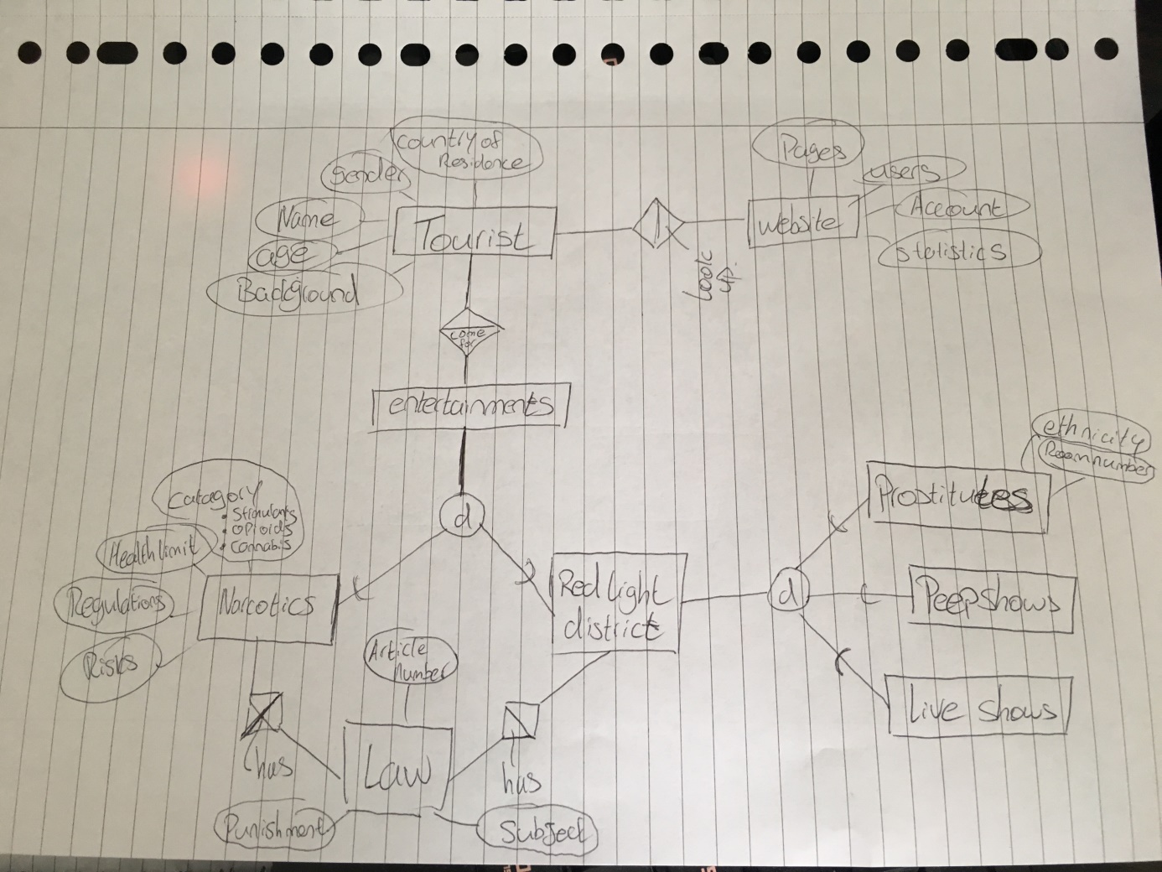

Draft logical model